File for the TURTLE/Earth Science of the 5 pointed star*
*Activities/Ideas like Stars-Ancestors-Descendants in the Tree/MilkyWay/River of Sky & Earth
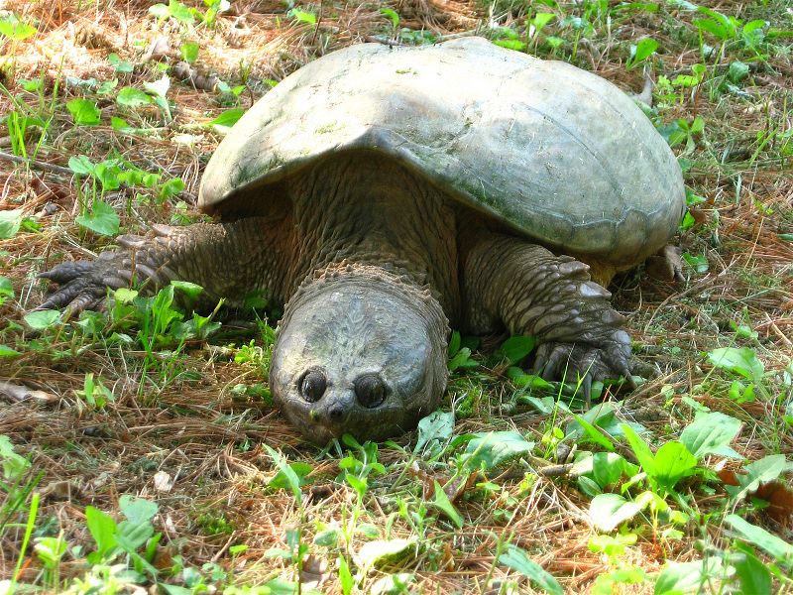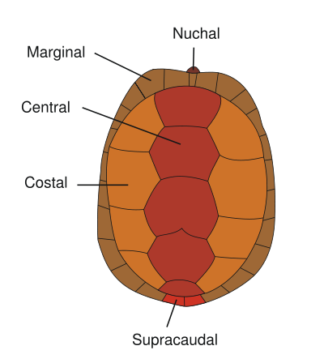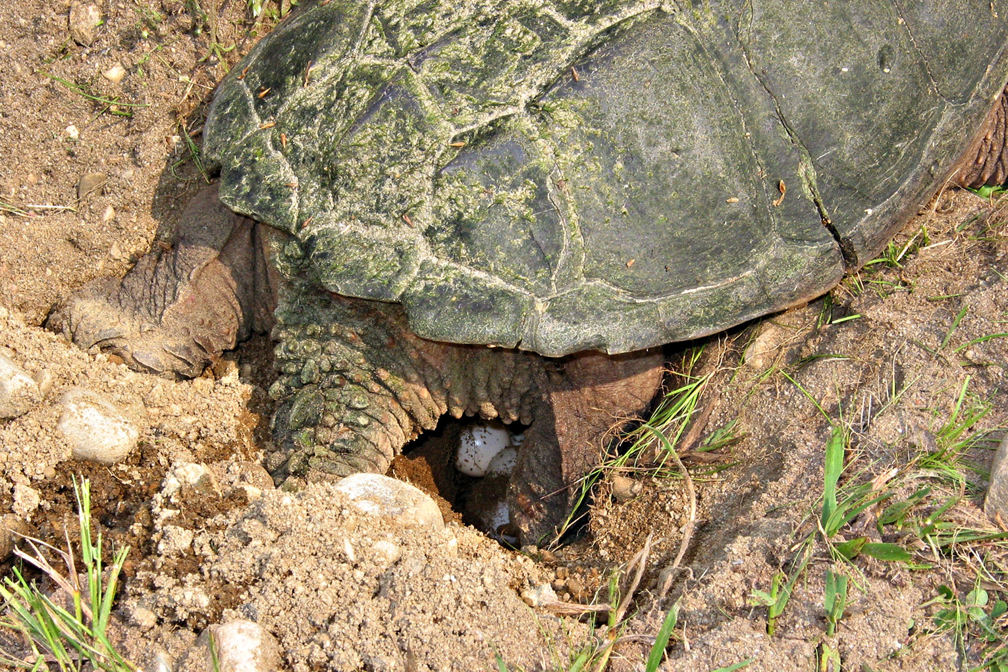

*Because the Earth Mother is said to be a Turtle…and because the Turtle shell has 13 Scutes and because the Earth scientists say that the Earth’s crust has 12 moving plates**… Research the names of those plates and begin to explain not only earthquakes and volcanoes and subduction zones that uplift mountain ranges including the Himalayas, but also tsunamis as these plates shift under the ocean releasing energy that spreads out like the powerful sound waves from the drum…Her Heart and the fiery Hearth of molten iron that beats beneath her shell.

**Which of the 5 “Platonic” mathematical shapes has 12 equal pentagonal faces?
What shape is the earth? [Dodecahedron…Oblate spheroid]

*See posters of “What shape is the Earth?” offering many alternative mathematical “worldviews”

*How could our Turtle-like Mother Earth also be like a soccerball (the rest of the Earth calls this a football) also called a truncated icosahedron? In what ways does this 60-cornered shape offer advantages when considering annual cyclical patterns of light and dark?

*Using trigonometry, what is the ratio of the area of all hexagons to the area of all pentagons on the truncated icosahedron?

* What does this have to do with the Earth?

*What does this ratio have to do with : a) Solstices? b) Rising Sea Level?

(Video) Building A New World (1993) University of Minnesota Institute of Technology. Skyline Displays, Inc. Elite Video Inc. [Architect designs one one-millionth scale earth model from truncated icosahedron “soccerball” displayed around world for 5 years to bring people together.]

Boyd, Robert S. (Aug. 26-2006) StarTribune. “Climate Rerun, Only Faster This Time.”
* Mauna Kea as tallest mountain on earth if measured from ocean floor at 31,824 feet versus Everest 29,035

Mone, Gregory (Aug. 2007). “The Buzz of the Earth” [Describes earth’s infrasonic natural sounds that elephants, dogs, etc. can hear.] p.66&67.

Epstein, H. and Quin Yu and J. Kaplan and H. Lischke. (July/Aug. 2007) “Simulating Future Changes in Arctic and Subarctic Vegetation”Computing In Science & Engineering. pp.12-23.

Mason, Philip. (1993). Schoolcraft’s Expedition To Lake Itasca: The Discovery of the Source of the Mississippi. Lansing: Michigan State Univ Press.

National Geographic (Sept 2004) Cover Issue: “Global Warming: Bulletins From a Warmer World.”

Video (1990)“Blue Planet” IMAX Smithsonian Institutoin/Lockheed.

Video(????) “Sacred Balance” with David Suzuki, E.O.Wilson and Wade Davis

Video (2003) “Chased By The Light” Jim Brandenburg [One season of daily 90 pictures with music by Michael Monroe]. Hamline Univ Press and Aurora Pictures and Cascade communications 1-800-346-9487.

Zarembo, Alan and T. H. Maugh II (Apr.7, 2007) Los Angeles Times “Dire Warming Report Too Soft Scientists Say.” p. 1A.

Zarembo, Alan and T. H. Maugh II (Apr.7, 2007) “As a Glacier Melts So Does A `Peruvian Water Supply” [For Cuzco]. Los Angeles Times. [Retreating at 600 feet/yr…smallest in 5000 yrs].

Bacon, David. “Water, Water Everywhere” Resource Center of the Americas vol.24 No. 2 Mar/Apr 2007 wwww.americas.org.

Powell, Eric (Jan/Feb 2005) Archaeology. “The Turqoise Trail: Did An Extensive Trade Network Link The American Southwest With Mesoamerica?” p.24-29.

(Nov 12, 2005) “Gone With The Flow: Ancient Andes Canal Irrigated Farmland” vol.168 no.20 www.sciencenews.org p.307

National Park Service magazine (2006) “Petrified Forest Celebrates Centennial!”
[Compared to 225 million years…about the same time since our sun spun once around the Milky Way galaxy!!]

