File For the RIVER/Astronomy/Space Science of the 5 pointed star*
*Activities/Ideas like Stars-Ancestors-Descendants in the Tree/MilkyWay/River of Sky & Earth
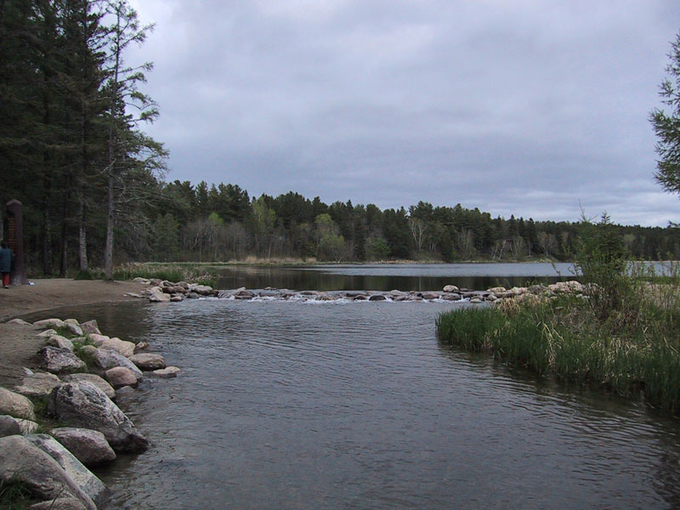
RIVER
MILKY WAY
TREE

*…The RIVER is... the MILKY WAY…
is the Sacred Cottonwood TREE is…!

*Use the Story of the Star as recorded by Dakota Elder Mary Louise Defender Wilson (MLDW) on “My Relatives Say” www.makoche.com
to explain how the star got in the sacred cottonwood tree/branch/twig/stem...an example of Indigenous STEM. Read her CD notes “The World Never Ends” regarding the use of stories, knowledge and wisdom for the generations and the improvement of human beings and civilization toward being more kind, gentle and helpful. Civilizations grow along Cosmic Rivers.
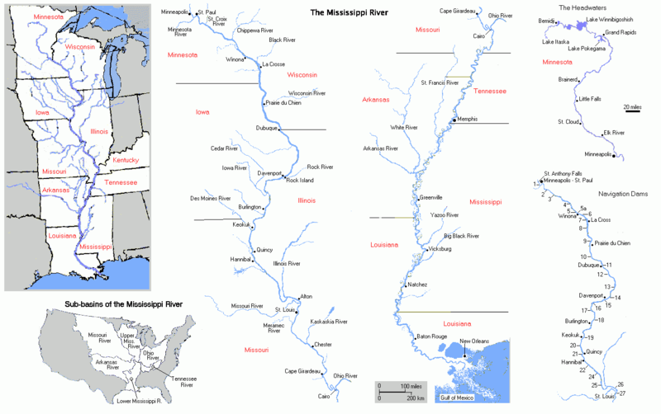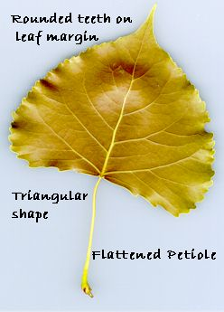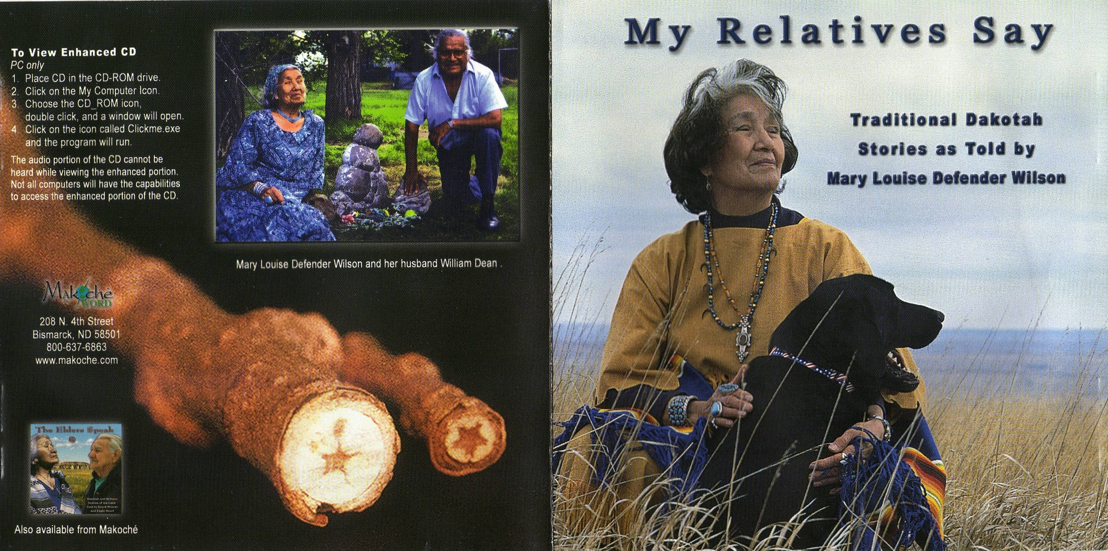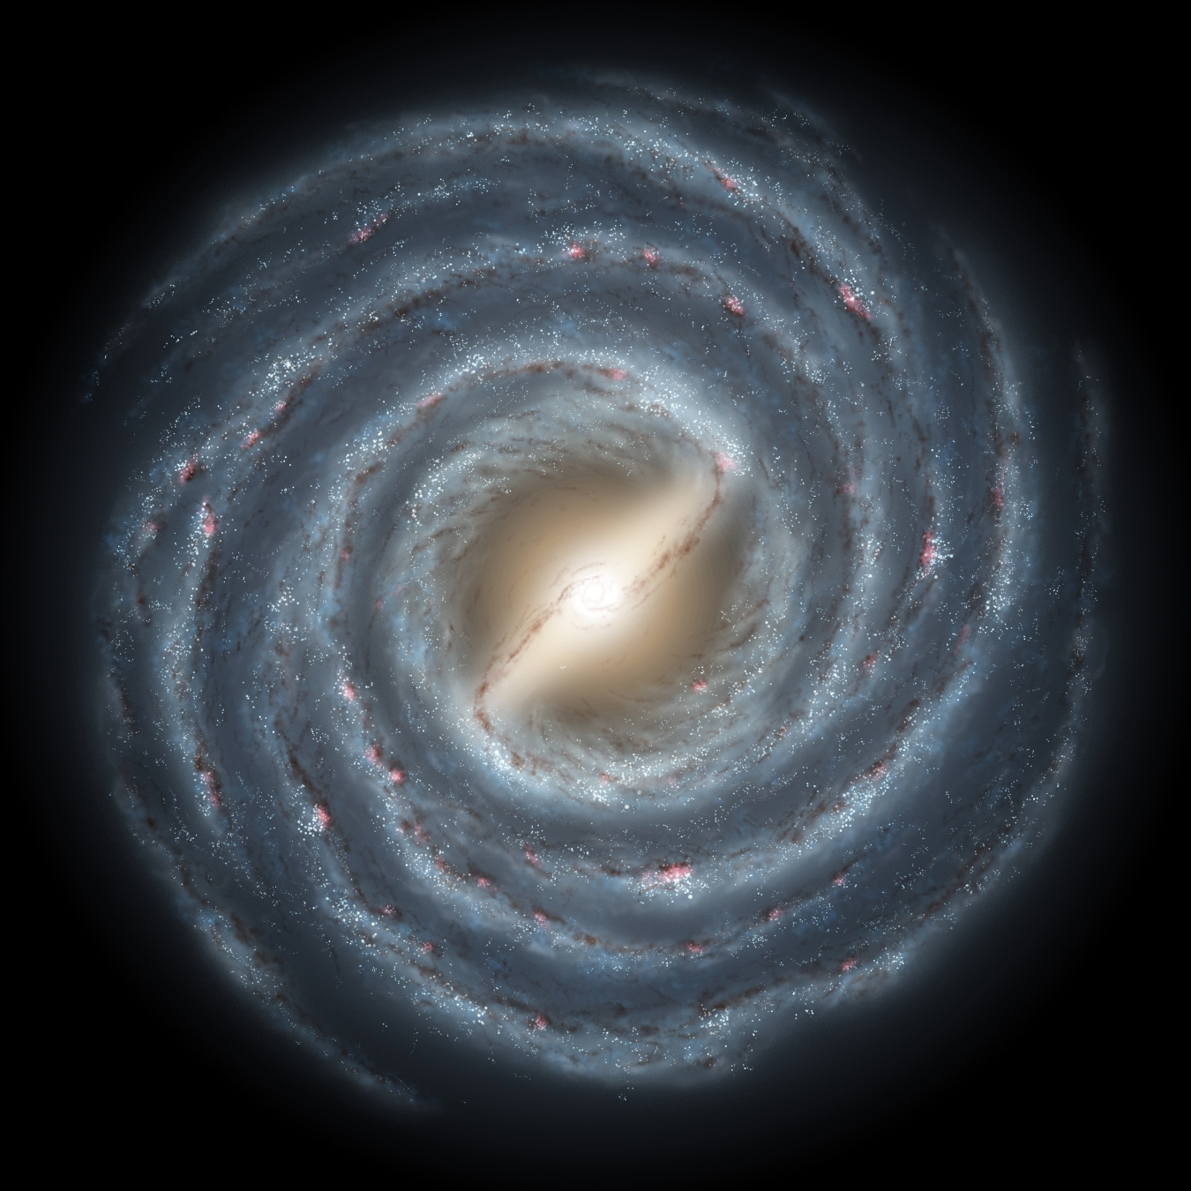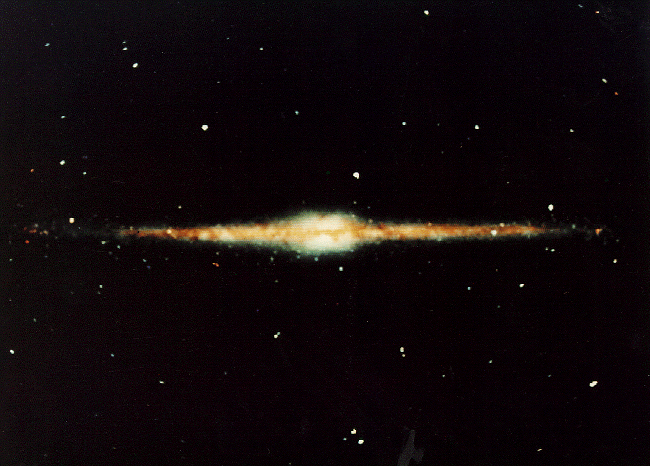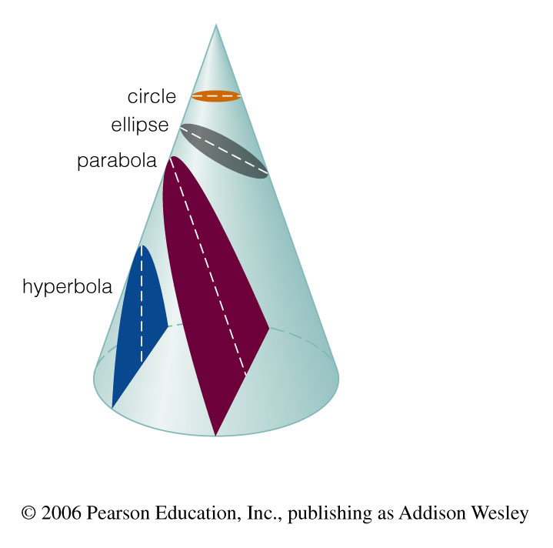

***Rock’s “Blue Rope River” idea shows how long ago the “St. Anthony Falls” of Wakpa Ha Ha Tanka/Misi Zibi were over in “St. Paul” 12,000 years ago instead of in “Minneapolis” and relative to this when Europeans’ first contact with the River was made versus when Indigenous hunters saw “Vega” as the North star and the Falls in St. Paul. Due to precession of the equinoxes(the 26,000 year wobble of our dancing Turtle Mother), “Polaris” is the North Star now but was “Vega” the North Star 13,000 yrs ago or “half a wobble” ago! So, if a quinoa/kinwa seed is a day, how many pounds of seeds ago was Vega the North Star? Also, consider how far apart certain stars really are if they are the average size of a quinoa/kinwa seed? Use calculator, VOYAGER software & Project STAR materials.
Sitting Bull said if it’s good, pick it up… otherwise, leave it alone. So try Project STAR or even COSMIC PERSPECTIVE course materials BUT with an Indigenous perspective and with critical decolonizing methodologies to better conscientize and decide how an Indigenous worldview/philosophy/CLAH not only had STEM and this “Milky Way-Big River-Astroscience”…but very early on… and even much more! The non-Indigenous view has recently begun to include some of our views of Sky-Earth relatedness under a sub-discipline called
ARCHAEOASTRONOMY…but even this is very underrepresented in most Western course materials including an otherwise very good one called Project STAR. You must apply Sitting Bull’s philosophy and significantly supplement the Whitestream diet with Indigenous “foods and cooking methodologies”…This is not a fast-food course of not-so-fun facts that go away after the test leaving an aftertaste and heartburn! It is an ongoing 26,000 year STORY that holds us all…

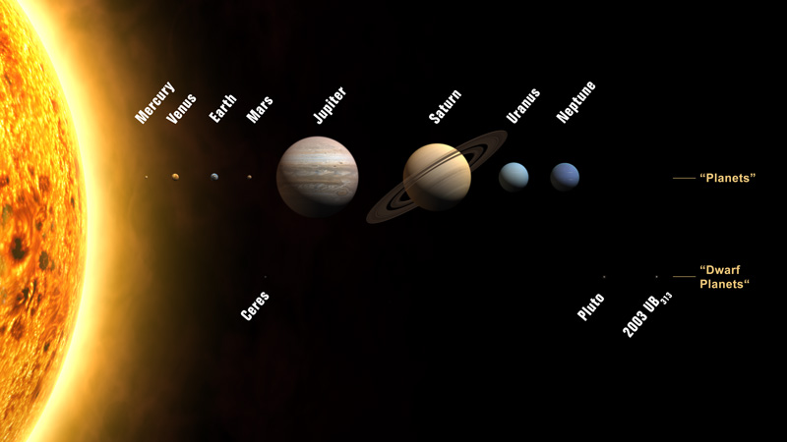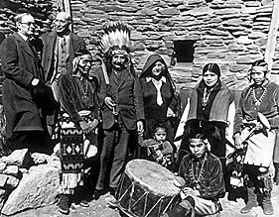

*Project Star: The Universe In Your Hands (1993) Harvard-Smithsonian Center for Astrophysics. Dubuque, IA: Kendall-Hunt Publishers. These hands-on materials will include a celestial sphere “sky dome” activity for tracking and measuring the sun’s path during daylight hours at various times of year. Use this dome activity with Aveni’s (1997) figure 2.2 showing the arch-like sunpath at Stonehenge @51 degrees N, Chichen Itza @20 degrees North and Cuzco @13 degrees South. Another Project Star activity, “3D constellations” uses red beads for various stars of certain constellations which are hung on different lengths of thread at the proper relative star distances from the surface of a black card. It also includes many activities for spectroscopy and other hands-on materials for building student make-and-take telescopes and understanding the role of the lens and mirror.
Their philosophy/worldview, from the introduction… “What is astronomy? It is a subject that deals not only with the Moon, Sun and stars but also with such topics as extraterrestrial life, black holes, the beginning of time, space stations, and the greenhouse effect. Astronomy also provides practical tools for measuring large distances and predicting the seasons. Some of these tools are important for a variety of professions, from farming through bridge-building to space exploration.
Astronomy is perhaps the oldest science. For thousands of years, human beings have tilted their heads upward and wondered about those twinkling points of light. We have also learned that they are like our sun but so far away that we can barely see them. We have walked on the Moon and sent spacecraft to the edge of the solar system. These accomplishments are the result of careful observation, scientific inquiry, and the technical application of scientific discoveries.
Scientists try to increase understanding about the universe and to make predictions about natural events. To do this, scientists build physical and mathematical models that enable them to test their ideas about the nature of the universe…It is through model-building that we came to accurately understand the sizes, locations, and motions of the Sun, the Moon, the planets, and the stars.
This book contains activities that will help you develop skills in observing and inquiry…We believe you learn science better by making measurements and observations than by memorizing “facts.” Understanding science also requires also requires understanding concepts, which are mostly much harder to learn than facts. But a single concept, or theory, can usually allow you to understand a large number of facts. Concentrating on a few fundamental concepts in a course results in more learning than treating many concepts in a more superficial way…Everybody has ideas about how the world works…your teacher should help you to test their accuracy by showing you how to make the relevant measurements and observations…” [The first half of the book’s activities are concerning our solar system and the second half is about measuring what’s beyond our solar system. The basic concepts are daytime sky, nighttime sky, celestial sphere, distances, sizes and angles, light, telescopes, earth, moon and sun, the paths of the planets, keeping it all together(gravity), stars, more about light, more about stars, the milky way, galaxies and the universe, odds & ends].

*Rock’s “XibalbArch/UkhupachArch/MictlanArch/Black&White& RainbowGrayArch” to show how a rainbow arch spun in the sky produces a dome and to illustrate clockwise versus counter clockwise motion of the planets, sun and moon (Counterclockwise/Eastward) versus the slow 26,000 year precession of the equinoxes (Clockwise/Westward). The Keystone design also works with the Kukulkan/Chichen Itza pyramid model to demonstrate equinoxes and with the alternating, dominating black and white surfaces to show the opposite hemispheric solstice patterns.

*Use Rock’s Rainbow Arch with Miwok story of “How Coyote Made the Rainbow.”
*Use ArchRivals game from Parker Bros. to demonstrate numerical and calendrical principles of balance (13) in addition to the Platonic and Archimedean solid numbers as applied to the Arch or Dome of the Sky for Rock’s CalendArch.

Price, Wassegijig Michael (Summer, 2002) “Anishinabe Star Knowledge” Winds Of Change AISES magazine pp.52-56. He describes various constellations such as loon, lynx, fischer, sweatlodge, hole-in-the-sky.

McClary, Timothy (1997) The Stars We Know: Crow Indian Astronomy and Lifeways, Little Bighorn College Waveland Press

*VOYAGER astronomy software for a desktop planetarium. Carina.

Videos related to Chaco Canyon:
- “The Mystery Of Chaco Canyon” (1999) The Solstice Project with Anna Sofaer narrated by Robert Redford w/ Joseph Campbell. Bullfrog films. <www.bullfrogfilms.com>

- “Chaco: Legacy In Stone” (2000) by Gray Warriner, Seattle, WA: Camera One.

- “The Sun Dagger: The Story Of America’s Stonehenge” (1983) The Solstice Project with Anna Sofaer. Narrated by Robert Redford. Bullfrog films. <www.bullfrogfilms.com>

* Analyze the Penasco Blanco petroglyph of the 1054 Supernova and use Voyager software to see the early morning sky in Taurus as it must have appeared on July 4, 1054 from the latitude of Chaco Canyon.

*Use 1974 Arecibo SETI message (designed by Carl Sagan) and compare it with DNA for any errors, also regarding the number of steps on human DNA.

*Use 1974 Arecibo SETI message and compare and contrast it with the Voyager 1&2 plaque’s message and then compare and contrast these with the Penasco Blanco petroglyph of the 1054 Supernova.

*Compare the Kukulkan/Chichen Itza equinox snake-shadow phenomenon with the Fajada Butte spiral(snake?) light “dagger” seen on the solstices and equinoxes.

*Compare and contrast the above snake ideas with the four snake petroglyphs which were drawn on cave ceiling Wakan Tipi cave (Unktehi’s home in the underworld) in Imni Za Ska Dan (now St. Paul). Use 106 Group references or websearch these petroglyphs before J.J.Hill blew up the cave and these petroglyphs for his railroad. Note: This sacred site is beside (and below) the arterial (Mississippi) Ha Ha Wakpa River… like the Milky Way River above. Note: Linguistic root word wak” runs south along the river and plains to Maya region after crossing the gulf with the birds that follow the river flyway south to Yucatan peninsula…The root word also is found in South America(Peru, Bolivia, Ecuador) Inca region also where the birds(tropical migrants of Two Worlds… such as the redbird “scarlet tanager” Piranga olivacea…puka pisqocha…chac chiic…zintkana duta/zintkala luta…miskobineshi…etc. It flies 3800 miles (one way) to be with its redbird relatives in a post-flight family reunion…to stay where it always summer as the equinox time tells it to fly north or south. From Tawantinsuyu to Red Lake!!!! It is 24,000 miles around Mother Earth’s Equator-Circle and a redbird’s roundtrip would be nearly 16,000 miles or nearly two-thirds the way around the East-West Equinox Equator Circle.

*Rock’s Red Bird song with Blackhawk.

*Use Frank Drake’s 1961 SETI Equation in 7 variables like searching the 7 directions for determining the number of “Redbird Relatives” out there…way out there… the Search For Extra-Terrestrial Intelligence and Astrobiology.

*See PBS video series “Origins…” with Neil DeGrasse Tyson; especially the episode called “Where are the aliens?”
* See DVD of X-Files Season 6 Episode: The UnNatural (Baseball playing Alien!)
*Consider how a camouflaged, shape-shifting alien like the octopus must have an incredible information processor(Brain-electrochemical neurotransmitter system). What if aliens look like the octopus? Note:8 tentacles like Periodic Table Families

* Tell Coyote’s Eyes story to understand what it’s like to see through the eyes of our relatives. His new buffalo eye is like a telescope. An infra red telescope would see like a reptile whereas an ultraviolet telescope would be like the eyes of some bees. We extend the human visual range and search for what’s out there and back there in time.

Jarvis, Seth (1991). Scrunch the Universe. Chicago: Capstone Press. [This has great suggestions for young people to understand relative scales of the cosmos. One great point is that there are about as many inches in a mile (63,360) as there are Astronomical Units in a Light Year (63,115).

*Show Powers of 10 video/website and Cosmic Voyage video. How does the Coyote’s Eyes story give us a macro- and micro- perspective like these videos? He learns to see small things with the microscope-like mouse eye and he learns to see far away things with the telescope-like buffalo eye.
* CD-ROM (1999) Powers of Ten Interactive. www.powersof10.com. Also a flipbook is available @ www.eamesoffice.com and the original 1989 and 1968 videos from the films of Charles & Ray Eames @ Pyramid Home Video Santa Monica, CA..

*(video) (1996 Academy Award nominee for best documentary) Cosmic Voyage narrated by Morgan Freeman.

* DVD of X-Files Season 6 Episode: The UnNatural [Airdate: 4-25-1999. About a baseball playing Alien! David Duchovny wrote and directed this episode. I believe he research and based it on the Mayan Popol Vuh because it involves Two Pair of Brothers who play ball and the story occurs over 52 years…Roswell Area, NM 1947 to 1999! DD’s biological brother has a cameo part in here as Piney the Catcher of the Grays team.
Also, there are two older brothers named Arthur Dent…like the first generation of ball-playing Twin brothers in the Popul Vuh! Of course the 260 day calendar was pre-Maya.
The People called the Olmec did not call themselves this. They were the first to use the 13x20 sacred calendar the Maya call Tzolkin. They used rubber and developed the ballgame in its cosmic, symbolic significance. See Jenkins. Read Childress and decide where hi and your bias lies in answering “Who were/are the Proto-Maya Olmec People?]

*Childress, David Hatcher (2007) World Explorer Vol.4 No. 6 “The Mystery Of The Olmecs: America’s Oldest Known Civilization” pp. 21-34.The name “Olmec” came in 1927 from Marshall Saville, a New York museum director who used this Mexica Nahuatl type name for “rubber people” for the those who lived in this area at the time of Spanish contact.

*Tezcatlipoca(Lord of the Night) is also the Big Dipper stars who along with his brother Quetzalcoatl/Venus gives us the always-moving sky calendar and the ways to count it and know it. Research the role of chocolate in astronomy/calendars and the gift of chocolate from “Venus/Morning-Evening Star/Quetzalcoatl. Use book by Parke & Panik.

Parke, Marilyn and Sharon Panik (1994). A Quetzalcoatl Tale Of Chocolate Fearon Teacher Aids PO Box 280 Carthage, Illinois 62321 ISBN 0-86653-959-X. I obtained this (also in Spanish) from a Spanish Teacher’s catalog through NINOS 1-800-634-3304. Many highly qualified consultants are listed with their qualifications at the end of this children’s book. There is also a Teacher’s Guide To A Quetzalcoatl Tale Of Chocolate which has many activity masters and much background information. ISBN 0-86653-957-3.
*For a good websource for information on the Yin-Yang like complementarity of the relationship between Quetzalcoatl and Tezcatlipoca: See http://weber.ucsd.edu/~anthclub/quetzalcoatl/que.htm
According to this source which cites others, Quetzalcoatl and Tezcatlipoca become two TREES at the creation of the fifth world (this one we’re in now)
that support and connect the sky and earth.

*The chocolate tree only grows between 20 degrees north and south of the 0 degree equator. Twenty…
like fingers and toes, and days in the Maya calendar, and now degrees north or south of the equator. What is the sun-plant connection? There is a correlation of chocolate to the stars particularly the North Star (Xaman Ek, Mayan) and to the cacao bean merchants who traveled north and south by following the star’s altitude above the horizon as they moved. So this North Star is the Heart of Sky and associated with chocolate. Cacao beans (Kakawa, Mayan) were used as a trade item like money, and as a counter for time units. So since chocolate grows on trees and is money and time…Time is chocolate is “money” growing on trees! …But the trees grow on/in and under/below the Turtle of 13!

*Compare and Contrast and Connect the lives of Schoolcraft, Hubble, Hawking and Herrington…as cosmic explorers…and their GUIDES!
*How has space already been “colonized?”

-Schoolcraft, Henry 1832 …without Ozawindib and his wife Obahbahmwawagezhigikwe would not be getting all the credit as an explorer/discoverer.
*Mason, Philip P. (1993). Schoolcraft’s Expedition To Lake Itasca: The Discovery Of The Source Of The Mississippi. Lansing: Michigan State Univ. Press.

-Hubble, Edwin 1923 Discovers galaxies…Island Universes

-Hawking studies the “end of these galactic rivers…not the Source/Head(Itasca) but the OutSource/Tail(NewOrleans?)

-Herrington John 2000? former NASA first Indigenous astronaut (Chickasaw).

Greene, Brian (2003) NOVA: WGBH The Elegant Universe: Superstrings, Hidden Dimensions, and the Quest for the Ultimate Theory. [String Theory “explained”]

(1997) Contact Warner Bros.

Kidger, Mark (1999) The Star Of Bethlehem: An Astronomer’s View. Princeton Univ. Press.

“Cosmology: Five Big Things You Need To Know” Discover (May 2007). pp.28-39.

Comins, Neil F. (1993). What If The Moon Didn’t Exist?: Voyages To Earths That Might Have Been HarperPerennial

Goodman, Ronald (1992) Lakota Star Knowledge: Studies In Lakota Stellar Theology Rosebud, South Dakota: Sinte Gleska University. [How the Black Hills of Earth is a mirror of the Gemini-Taurus-Orion-Milky Way region of Sky].

Douville, Victor (2005) Lakota Astronomy And Its Application To The Emergence- Genesis Of The Oceti Sakowin In The Black Hills (He Sapa). Rosebud, South Dakota: Sinte Gleska University.

Bruchac, Joseph and Gayle Ross (1995) The Story Of The Milky Way: A Cherokee Tale New York: Dial Books.[Great Spirit Dog with Conrmeal Spilling from its mouth].

Nelson, S.D. (2003) The Star People: A Lakota Story. New York: Abrams Books.

Goble, Paul (1985/1991) The Great Race Of The Birds And The Animals. Aladdin Paperbacks.
Aveni, Anthony (April 2001) “Other Stars Than Ours: Aztec Astronomers Had Their Own Reasons For Sky Watching” Natural History. pp.66-73.
Filsinger, Tomas J. (1984) The Aztec Cosmos. Berkeley, CA: Celestial Arts

