File for the HEART/Life Science/Biology of the 5 pointed star*
*Activities/Ideas like Stars-Ancestors-Descendants in the Tree/MilkyWay/River of Sky & Earth

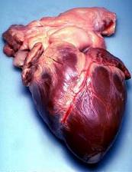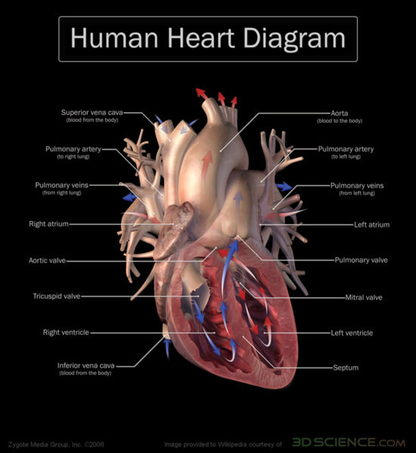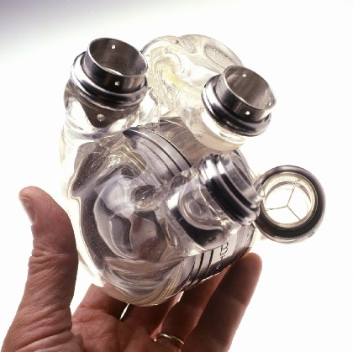

*What does it mean to be ALIVE? Wiconi… Bimadiziwin…Heart of Sky--Heart of Earth
Each form of Life has its place in the Story…its many relationships to the Whole. According to scientists, Life seems to be defined by whether it has DNA and a list of qualities making it “alive.” But in the Indigenous Worldview/Philosophy, everything is alive and has Spirit even if it has no measurable DNA or pulse. Therefore everything is a Relative treated as though its Story is worthy of being told, listened to and known. Then, there is the Spirit Life on the other side of the Matter-Energy Doorway that seems not to need Matter to move through the Door at times…

*Is the HEART of a cell its DNA…or is the HEAD of a cell its DNA? Head-Heart-DNA!
Some might say the mitochondria is the heart…the energy center that keeps everything moving, circulating…See the amazing structure of LH2 Light Harvesting Devices in the bacterium known as R. Acidophilus. Discover (Dec. 1995). pp.89-95.

*When does Life stop being alive? If the HEART is a DRUM, does the music ever end or does the dancing continue? The TURTLE’s HEART is very strong and will continue to play its song…

*The “lub dub” sound is from the closing of the valves like the beats and honor beats on the drum. The 4 chambered heart is like the 4 directions and the four seasons separated by the 4 special days of 2 equinoxes and 2 solstices that mark the circulating pattern of light and dark. There are 4 days between these 4 days as well, called “cross quarter days.” 4 chambers and 4 valves are like 4 blood types and the Rh positive or negative factor which totals 8 possible combinations of blood types…to consider in a transfusion…or not…

*When does the natural Heart become artificial? Koyaanisqatsi (Hopi)…With how many artificial valve implants? How many artificial valves have been implanted since the early years?
* Research the: 1) AbioCor artificial heart and the 2) Bakken Museum/Library and 3) St. Jude Medical Heart Valve Division…the last two mentioned are here in the Twin Cities which is where the Rivers meet and is like a Navel or Heart with the Mississippi as the Aorta from Her Heart…the Heart of the Earth Mother.

* Compare and contrast the Twin Cities to a 4-chambered Heart. When we add dams and bridges to these living arteries to harness their power to grind wheat and saw lumber…do we cross these bridges with out noticing the value of life and the Heart? Do we too easily take it for granted? The Heart of our Twin Cities went into atrial fibrillation…In the end does gravity win? The I-35 freeway bridge collapse reminds us of our dependency on technology, arches, stress loads and physics (cross-reference to DRUM/Physics… Use Archrivals Game and Rock’s Black & White Rainbow Gray Arch… XibalbArch/Ukhu-PachArch/MictlanArch…For RIVER/Astronomy/Space Science… the Sun is the HEART of our solar system yet Life is here…and/or not just here…so where?)

*We must guard our hearts against the Windigo/Cannibal Monster Wizard…
Read/Tell the Seneca story called “Turkey Boy Squeezed the Hearts of Sorcerers”

Bruchac, Joseph (Winter 2001). “The Place Of The Heart” Parabola: Myth, Tradition, and the Search for Meaning. pp. 85-89. “Where do we live, learn, hunt, and dance? [Turkey Boy sees strawberries the size of hearts at the lodge of the Wizard Deadoendjadasen and his seven evil sisters. He meets Skin Boy on a pole who tells him where their 8 hearts are hidden…he gets them, smashes them onto a rock one by one where they each “cracked open like a flint stone” He then frees Skin Boy who turns out to be his lost brother and they bring back to life all of his people whom the cannibal wizard had eaten.]

*Compare this with the Hallmark (2003) Dreamkeeper video story of “The Giant Serpent” whose 7th heart must be hit perfectly with a magic arrow.

Ozelli, Kristin Leutwyler (Sept. 2007) Scientific American issue: Diet, Health and the Food Supply. “This is Your Brain On Food” pp.84-85. Neuroimaging reveals a shared basis for chocoholia and drug addiction.
*In what ways are we are our own heart-eating and/or removing cannibal monster wizard if we remove S.T.E.M. from C.L.A.H.?

Shapiro, Robert (June 2007) Scientific American Cover: “Did This Molecule Start Life? Forget DNA and RNA. Maybe It All Began With Something Much Simpler” “A Simpler Origin For Life” pp.46-53.

Church, George. (Jan 2006) Scientific American “Genomes For All” pp.46-54. [Inexpensive gene readers will soon unlock the secrets in your personal double helix].

*Video The Last Mimzy movie contains information on the Genographic Project by IBM and National Geographic where anyone can send in their DNA sample to a database so they’ll have more information on where are geographic DNA family tree and its branches and twigs originate.

*Consider the ethics of DNA data non-privacy. Especially consider the HGDP Human Genome Diversity Project as a branch of the Human Genome Project which announced it had read the entire human genome in 2000. The director who announced this with Pres. Bill Clinton has a book out called: The Language Of God

Collins, Francis S. (2006). The Language Of God: A Scientist Presents Evidence For Belief. New York: Free Press. [He builds a case for Theistic Evolution which he proposes be rename as BioLogos. He is not endorsing Intelligent Design.]
*If DNA is the Language of God…what are the ethics of corporations patenting it for profit? From wild rice to 722 Indigenous global population whose DNA might contain medical marvels for the pharmaceutical industry? Who can commoditize Life/DNA? THEY can! What’s new? See LaDuke (2005) and Deloria (1979) & (2002).

Begley, Sharon (March 19, 2007) “Beyond Stones & Bones” Newsweek pp.52-58. [Homo Erectus was not our ancestor] Cover: “The Evolution Revolution: The New Science Of The Brain and DNA Is Rewriting The Story Of Human Origins”].

* Make Soda/Pop Can DNA… Use alternating Sprite and Pepsi Up one side of the DNA Ladder and Down the other side of the Ladder for Sugar and Phosphate…For nucleotide base pair steps use A &W Root Beer for Adenine and Tahitian Treat for Thymine. Use Coca Cola and the Golden Kola…Inka Kola [if you can find it. This was originally from Peru, Ecuador and Bolivia…first Canada Dry and now Coca Cola are importing it] for Cytosine and Guanine.
*Note: the name GUANINE is from GUANO the Spanish word for the Inka/Quechua word Wanu meaning bat droppings which are very rich in Nitrogen used as fertilizer and for explosives by Germany in WWII. SO WE FINALLY HAVE AN INDIGENOUS WORD IN SCIENCE TERMINOLOGY! …And it is one of the four (4) chemical letters of the Ladder of Life molecule… If not a Ladder…a Giant Serpent or perhaps the upward circling flight of an Eagle on a rising thermal updraft.
You don’t have to collect 3 million pair of steps though…but have students measure a certain length of these can-molecules and do the math for how long HUMAN soda pop can DNA is…Does it reach to the Moon?

Narby, Jeremy (1998) The Cosmic Serpent: DNA And The Origins Of Knowledge. New York: Tarcher Putnam [He learned of tobacco’s role in South American people’s ability to see DNA molecules which were described as…”the mother of the mother of Tobacco is a Snake.” He admits and promotes that Indigenous people were able to know the shape of DNA for at least centuries if not longer.]

HIV/AIDS as a Poisonous Serpent DNA Molecule waiting to strike…
(????) Common Ground, Protecting the Generations: An HIV/AIDS Prevention Education Tool. Video and Teacher’s Booklet of activity masters and ideas. Tulsa OK Tulsa Public Schools and Chickasaw Nation Youth Services. Funded by CDC through Oklahoma State Dept. of Ed.

* Snake imagery in Egypt and Celtic Ireland…as DNA? Or a calendrical symbol…or both?

West, John Anthony (1993) Serpent In The Sky: The High Wisdom Of Ancient Egypt?. Wheaton, Ill. Theosophical Publishing House.

Condren, Mary (1989) The Serpent and the Goddess: Women, Religion, and Power in Celtic Ireland: Harper SanFrancisco.
*Diabetes…genetic factors, the role of flour, frybread, colonization, loss of indigenous foods, obesity, etc. Pima, other nations…
* Rock wrote a document for MHS and Mill City Museum…visit the museum, think about JJ Hill and ask yourself: What is the contributing role of flour in the diet of First Nations people and our alarming rate of diabetes at 10 to 15 times higher than the US average?

* American Diabetes Association Diabetes Expo Oct. 13, 2007 @ Mpls Conv. Center

* Get involved with, visit, or make your own traditional garden program with heirloom seeds…such as the Turtle Effigy Garden at the Science Museum of Minnesota or the Dream Of Wild Health Program near Hugo. See article of:
(Aug. 26, 2007) “A Dream Growing Wild” StarTribune. p.1B.

Bruchac, Joseph (1991) Native American Stories. Golden, CO: Fulcrum.

Bruchac, Joseph and Michael Caduto (1991 ) Keepers of the Animals: Native American Stories and Wildlife Activites for Children. Golden, CO: Fulcrum.

Bruchac, Joseph and Michael Caduto (1989) Keepers of the Earth: Native American Stories and Environmental Activites for Children. Golden, CO: Fulcrum.

Bruchac, Joseph and Michael Caduto (1988) Keepers of the Earth: Native American Stories and Environmental Activites for Children: TEACHERS GUIDE. Golden, CO: Fulcrum.

Nyberg, Lee ed. (1993) Earth’s Caretakers: Native American Lessons. MASTERS Project Math And Science Teachers for Reservation Schools. Lawrence, KS

Pellowski, Anne (1990) Hidden Stories In Plants. New York: Macmillan.

Tompkins, Peter and Christopher Bird (1973) The Secret Life Of Plants: A Fascinating Account Of The Physical, Emotional, and Spiritual Relations Between Plants And Man. New York: Harper & Row.

Maxwell, Nicole (1990) Witch Doctor’s Apprentice: Hunting For Medicinal Plants In The Amazon. New York: MJF Books.

Mann, Charles (2005) 1491: New Revelations Of The Americas Before Columbus. New York: Alfred Knopf.

Weatherford, Jack (1988). Indian Givers: How The Indians Of The Americas Transformed The World. New York: Crown.

Weatherford, Jack (1991) Native Roots: How The Indians Enriched America. New York: Fawcett Columbine.

(Video/DVD) (2003) Mariposas: Mariposario Xcaret Monarca “La Leyenda” Monarch Butterfly Migration Sanctuary and the Legend of the returning souls with day of the dead, etc. www.mexicoantiguo.com.mx
(Oct. 17, 2004) “Monarchs On High” Star Tribune p. G1. Describes the migration and life cycle.

(August/September 2003) The Cardinal “Monarch Butterflies and Citizen Scientists: Unraveling Majestic Secrets. St. Paul Audubon Society. Dr. Karen Oberhauser guest speaker on Sept. 11, 2003 has been studying monarch behavior since 1984. She has “Monarchs in the Classroom” program and Monarch Larva Monitoring Project.

(Aug. 5, 2007) Star Tribune “Kids Dig S. Dakota’s Mammoth Site” p.G6.

* Get involved with the Wildlife Science Center just north of the Twin Cities.

Johnson, Eli (May 2007) “Sacred Tobacco Campaign” The Circle Vol. 28, Issue 5.

Johnson, Eli (June 2007) “Sacred Tobacco Campaign 2” The Circle Vol. 28, Issue 6.

